**Exercise 5.2** Go back to the first example, [DynamicExample.java](http://www2.seas.gwu.edu/~simhaweb/java/modules/module5/examples/DynamicExample.java), and draw the memory pictures for this example at various points in the execution of main().

|  |
| --- |
|  |

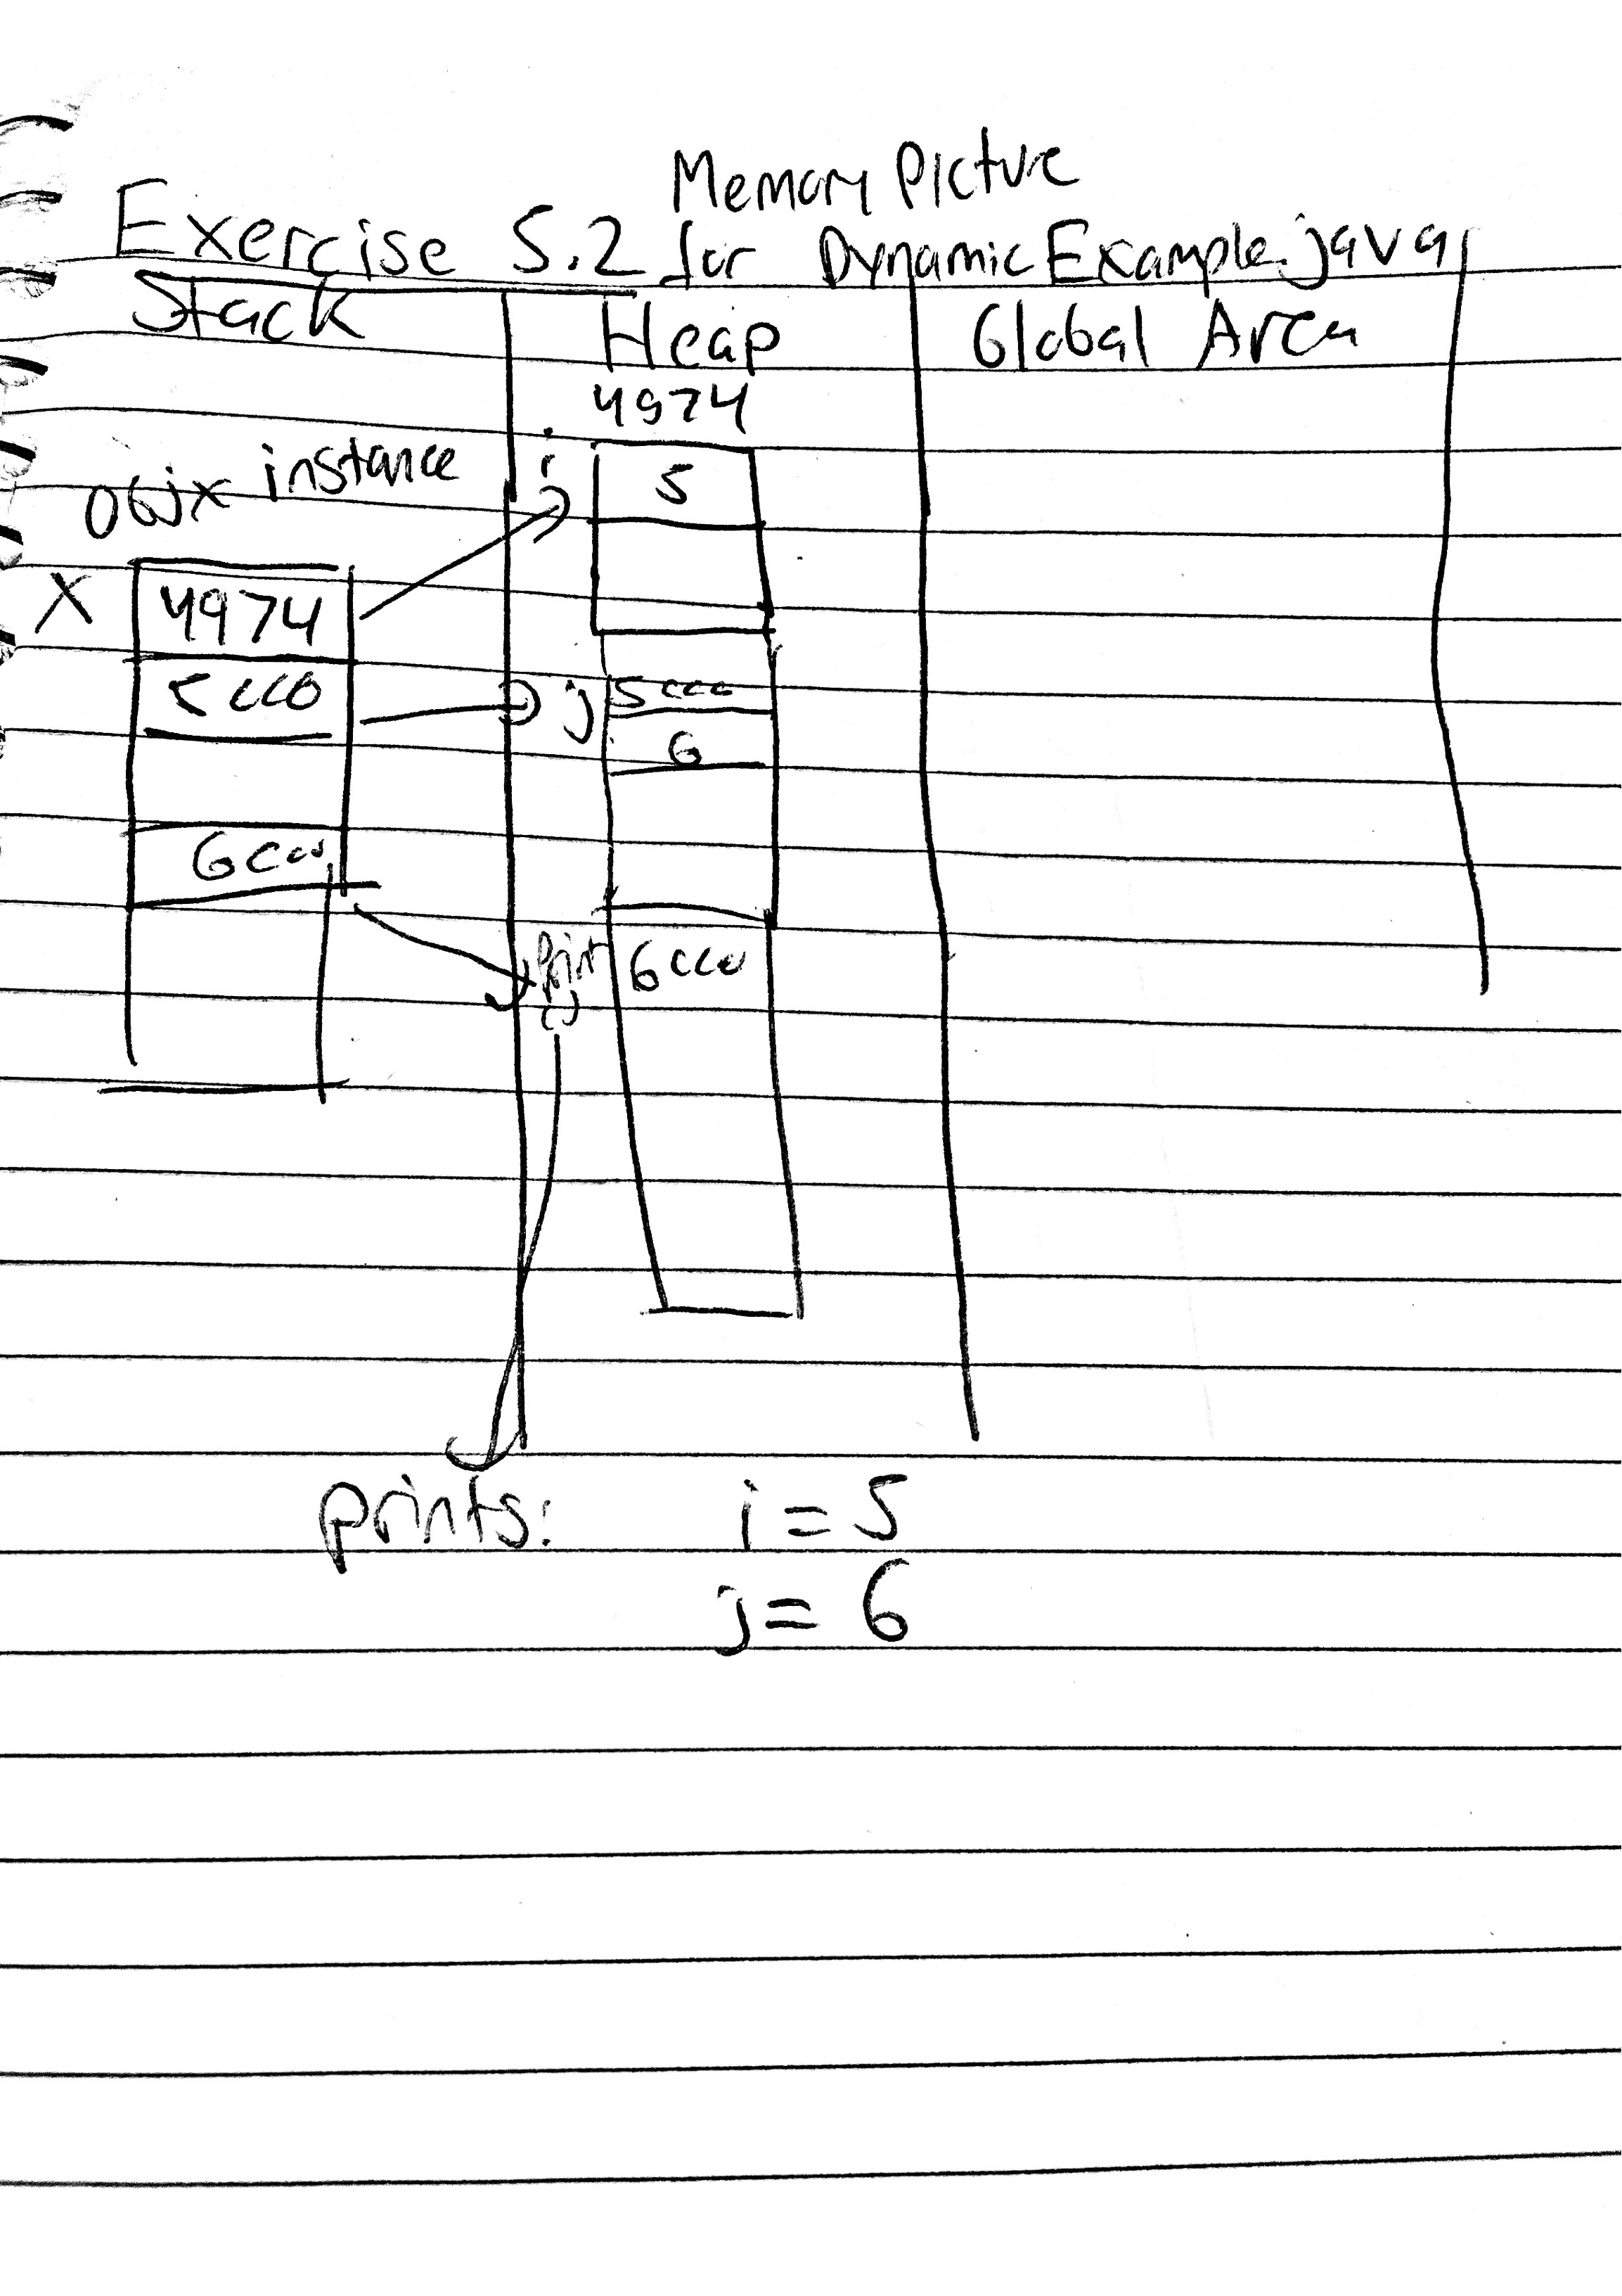

**Exercise 5.3:** Consider the example below and draw the memory picture just after the execution of x2.i=6

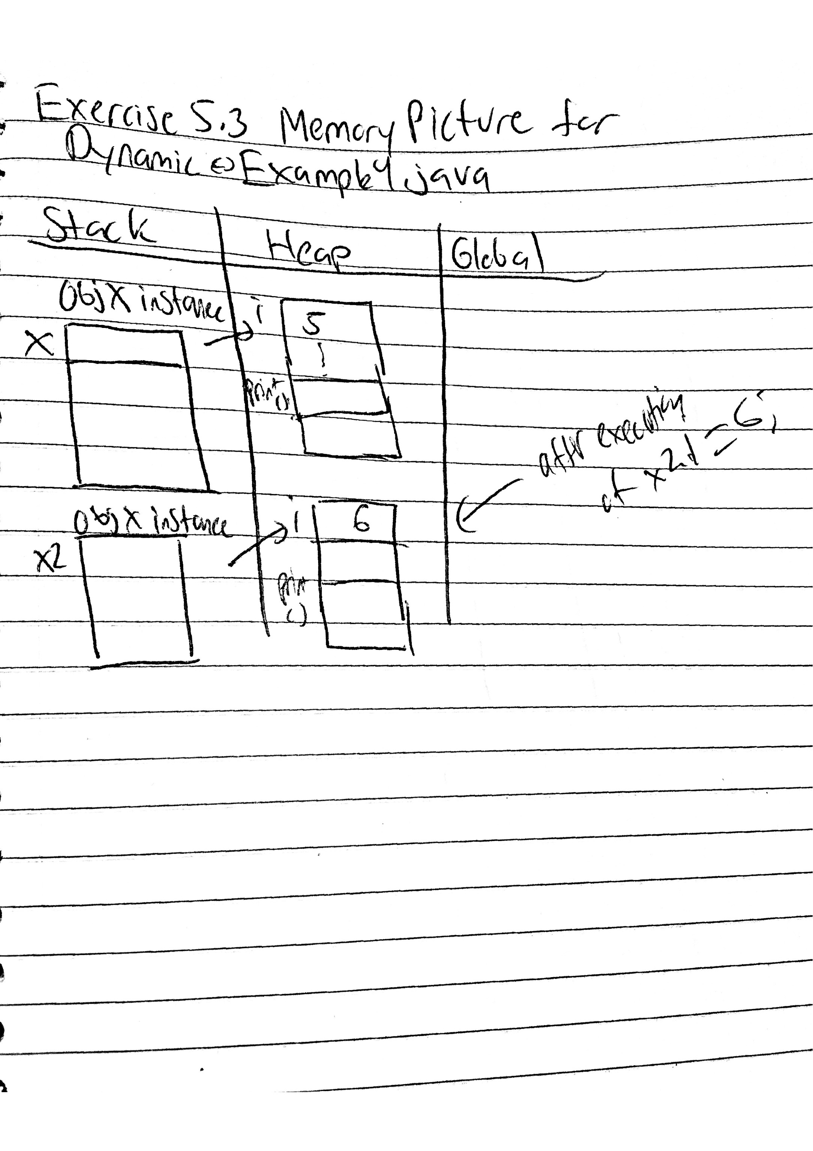

**Exercise 5.4:** Consider the example below and draw the memory picture just after the execution of x2.i=6

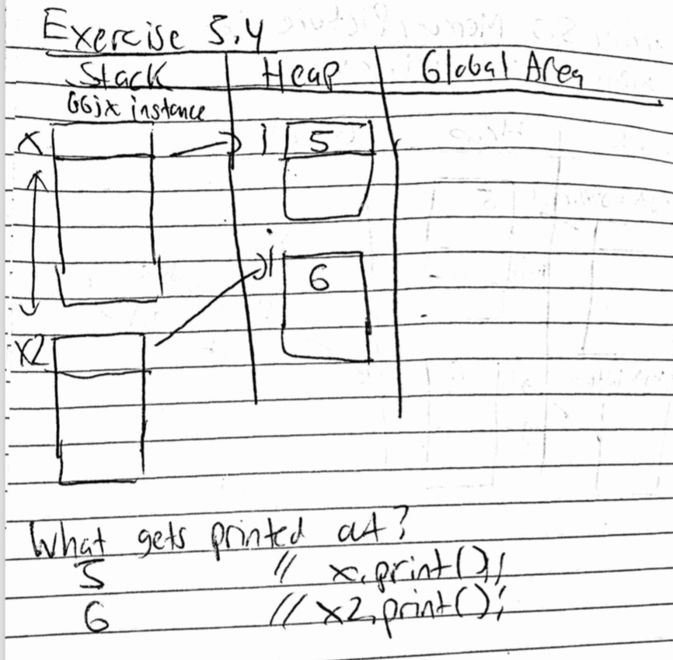

**Exercise 5.5:** What is the memory picture just after executing the only line in printTheObject(), but before the method returns?

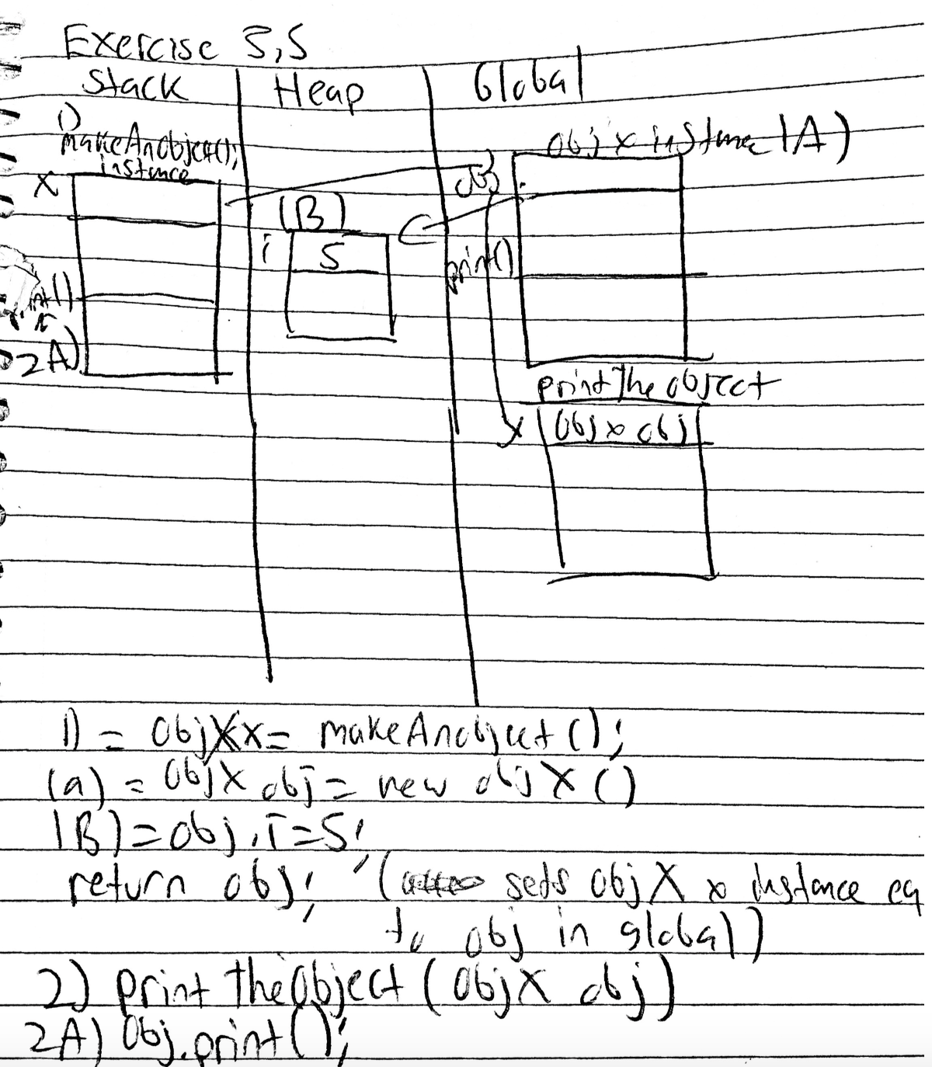

**Exercise 5.6:** Download [DynamicExample8.java](http://www2.seas.gwu.edu/~simhaweb/java/modules/module5/examples/DynamicExample8.java) and draw the memory picture just after the last statement in main().

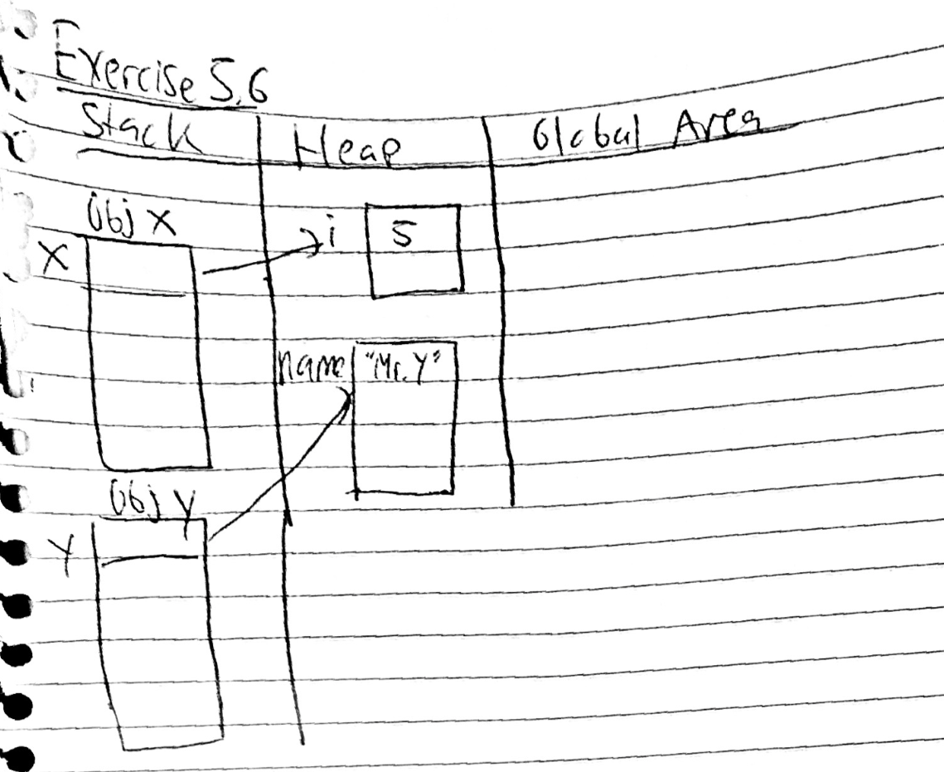

**Exercise 5.7:** Draw the memory picture after the last line executes in main().

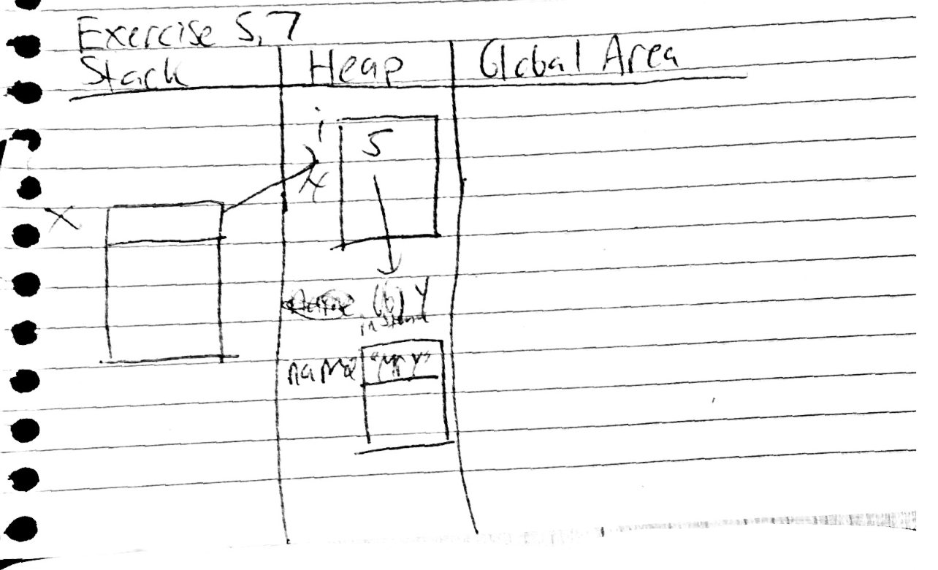

**Exercise 5.8:** Draw the memory picture after the last line executes in main().

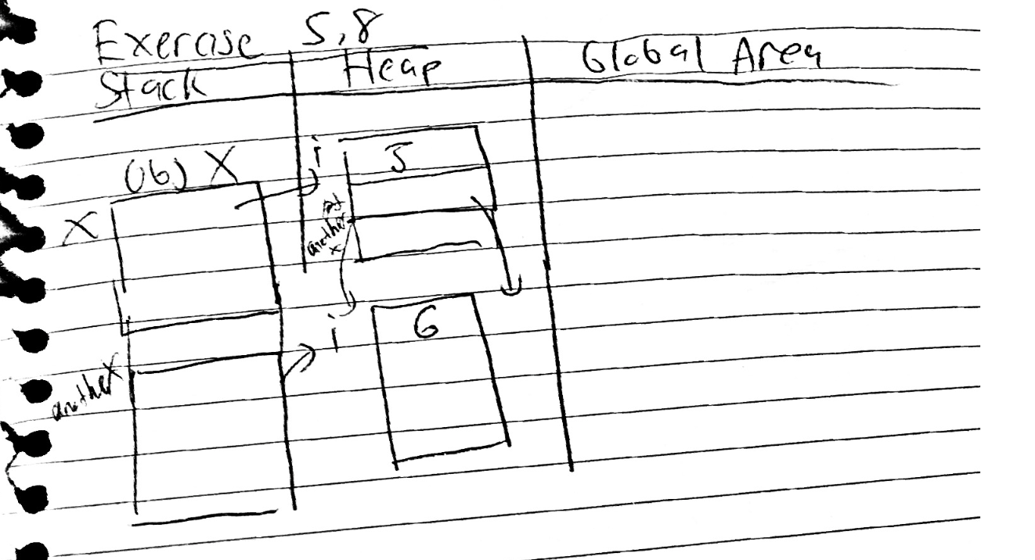

**Exercise 5.9:** Download the [above program](http://www2.seas.gwu.edu/~simhaweb/java/modules/module5/examples/DynamicExample11.java), compile and run. Now remove the toString() method from ObjX, compile and run. What do you see?

Before removing the toString() method from ObjX it prints:

i=5

Object x: i=5

After removing the toString() method from ObjX it prints:

ObjX@7852e922

Object x: ObjX@7852e922

It prints the memory address which is what toString() does by default instead of the value of i when you do not override the default toString() method.

**Exercise 5.10:** 

Declare the two variables inside your class Complex as static. Does it work? Explain.

Yes, declaring the variables for realPart and imagPart as static still works because you are creating an instances of complex in the main method, if you were not creating instances in the main method then declaring the variables would not work (they would need to be dynamic objects)

**Exercise 5.11:** (in folder with code)

**Exercise 5.12:** Consider these two familiar lines of Java code:

System.out.println ("Number of primes below 100: ");

System.out.println (25);

* What is out? Is it a class? A method?

**System is a class that is included in the java.lang package. “out” is a static member of this class, it is in particular an instance of java.io.PrintStream. It is not a class or a method but a variable that is used to to initialize the PrintStream constructor.**

* Where do you find the println() method? What is its signature?

**Just like “out”, println() is a method found in java.io.PrintStream in the java.lang package. Its signature is println(), the default return type is void so it has no parameters. However, every time you use it, you are overloading the default method in order to print what you put in the parentheses using the**

**Exercise 5.13:** (code in folder)